**Technology Resources to Promote at Home Learning**



**\*\*All these resources need to be accessed through Clever\*\***

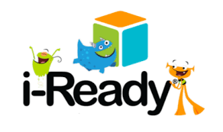

i-Ready Personalized Instruction provides students with lessons based on their individual skill level and needs, so your student can learn at a pace that is just right for them. These lessons are fun and interactive to keep your student engaged as they learn.

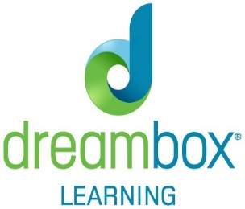

[This Photo](https://en.wikipedia.org/wiki/DreamBox_(company)) by Unknown Author is licensed under [CC BY-SA](https://creativecommons.org/licenses/by-sa/3.0/)

DreamBox Learning is an effective online math program that teaches and adapts to provide an individualized learning experience. DreamBox goes beyond the right or wrong answer.

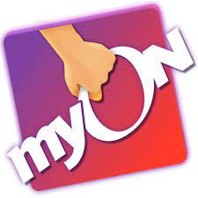

**A personalized digital library at every student’s fingertips**

Renaissance myON® Reader is a student-centered, personalized literacy environment that gives students access to more than 6,000 enhanced digital books. Titles are dynamically matched to each individual student’s interests, grade and Lexile® reading level.